Company Travel Policy Template

Company Travel Policy

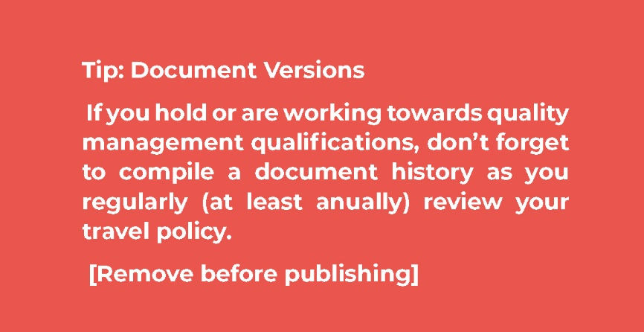

Document Control

Process No. and Name
Process Owner
Process Version Number
Issue Date
Summary of Process
Teams affected by Process

Version History

Version Number | Date | Compiled by: | Approved by:

Contents

**Insert contents table here**

Introduction

This travel and expenses policy has been compiled to outline the rules for booking travel and dealing with travel-related expenses for [Company Name].
This policy is relevant to anyone in the company who travels for work, as well as teams involved in supporting and managing travel. This policy applies to all members of staff who work under a contract of employment with [Company Name] and to members of the Board. It also applies to agency staff, contractors and others employed under a contract of service. All prices/rates listed in this document are exclusive of VAT unless otherwise specified.
The key aims of the policy are:
- To safeguard travellers and make sure they are supported when away from the office and representing the company;
- To reduce administration time required for corporate travel;
- To clearly lay out the rules for travelling, for all staff.
It is important that all staff involved in business travel read and understand this policy. Please contact [Name and email] with any questions you may have.

Supporting Travellers

For [Company Name], our first priority is the safeguarding of our staff both in and out of the office.

Whilst Traveling
If you require support for issues involving your travel such as hotel problems, cancellations or flight difficulties, contact the support team of [Chosen Booking Platform/Internal Travel Management Team] below:
During Office Hours | [Chosen Booking Platform/Internal Travel Management Team] | [Phone Number/Email Address]
Out of Office Hours | [Chosen Booking Platform/Internal Travel Management Team] | [Phone Number/Email Address]

Emergencies
If you encounter an emergency, please call the emergency services first, if this is necessary. After doing this, please contact [Insert Manager or Key Employee Details].
For travel insurance issues, please contact [Travel Insurance Provider]. If you are unsure about contacting the insurance company with your query, please contact [Insert Manager or Key Employee Details]. The Details of our policy are listed below:
Policy Number:
Contact Number:
Account Manager:

In-Country Support
In some locations, we use a travel risk management and security provider to help with staff safeguarding. Please check before travelling for contact details in-country. The details of our current provider are listed below:
Contact Number:
Contact Details:

Booking Travel
It is essential that you use [Chosen Booking Platform/Travel Provider] for all business travel to make sure that all travel can be tracked and accounted for within our approved platform. If you are unable to book via the tool, please contact [Chosen Booking Platform/Travel Provider] on the below details:
Account Manager:
Phone Number:
Email Address:

All trips should be approved by [Manager, Team Supervisor or Other Role]. Employees may book trips online using [Chosen Booking Platform/Travel Provider]. In this policy, all restrictions and rules for booking travel are included, but this can also be found at [Chosen Booking Platform/Travel Provider]. Any necessary exceptions outside of the travel policy will need to be approved by [Manager, Team Supervisor or Other Role].

Passenger Information
Please make sure that all information for travel is submitted and kept up to date on the [Chosen Booking Platform/Travel Provider] website. This will help to speed up bookings and make sure that you travel in as much comfort as possible. This includes:
- Passport number;
- Travel preferences;
- Frequent flyer program memberships;
- Hotel loyalty memberships;
- Visa details;
- TSA re-entry and frequent traveller details

Extending a business trip for leisure
We allow extensions of business trips for leisure under the following circumstances:
- You have sufficient annual leave to cover the extension;
- The annual leave period is approved by your manager;
- The leisure extension does not affect the reason or purpose of the business trip.

Employees are responsible for all costs during the leisure extension, including hotels, food and all travel except for the return flight (this includes additional days of car rental hire, if relevant). Travellers must book the trip at least [X] days in advance for domestic travel and [X] days in advance for international travel. Any increase of flight or transport costs must be covered by the traveller beyond [X]%, due to a change of return date.

Staff Wellbeing

Travelling can be stressful and incredibly tiring. Employees should understand the effects that travelling and being away from home can have on their physical and mental health. A World Bank study showed that almost 75% of those traveling for business reported high or very high stress levels. Below are a list of rules to help safeguard our teams and improve the quality of your business trips.

- No more than [X] meetings should be held in one day.
- When working past 10pm (meetings, client entertainment, etc), employees may start work [X] hours later than their usual start time.
- Employees should not start a car journey later than 6pm if longer than four hours. In these circumstances, employees should stay overnight at a hotel.
- If checking in to a hotel past 7pm, employees should email their manager to confirm arrival.
- Employees should not travel more than [X] miles/kilometres by car per calendar day.
- If you become overwhelmed or have any issues with the level of travel, you should contact [Designated Employee and Email Address].

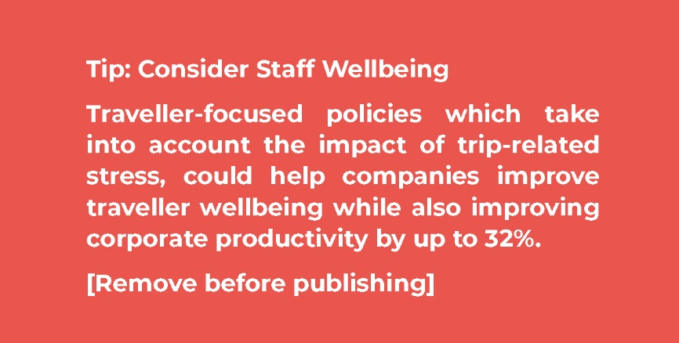

Hotels

All hotel stays should be booked through [Chosen Booking Platform/Travel Provider] to ensure effective tracking and reporting.
Employees should always book standard rooms, unless room upgrades are offered on arrival at no additional cost.
The standard price per night is [£X]. Some cities and regions have different spending caps. These can be found at [URL/Travel Provider Platform].
Travellers should choose from approved and preferred hotel chains which can be found at [URL/Travel Provider Platform]. A list of restricted hotel chains can be found here also.
Travellers must not stay for longer than [X] days per city. Some cities and regions have different stay caps. These can be found at [URL/Travel Provider Platform].
- [Company Name] will cover the following additional hotel services:
- Wi-Fi;
- Hotel Parking;
- Breakfast (where it does not breach the nightly cap);
- Meal deals (where it does not breach the nightly cap).

Homestays & Rentals

Employees may book homestays or apartments on sites such as Airbnb, VRBO and similar, as long as the rate is compliant with this policy and not above nightly caps. Any property rising above this will require authorisation from your manager.

Flights

All flights should be booked through [Chosen Booking Platform/Travel Provider] to ensure effective tracking and reporting.
- Employees are required to fly economy on all trips as standard.
- Employees should choose from approved and preferred airlines which can be found at [URL/Travel Provider Platform]. A list of restricted airlines can be found here also.
- Where approved by a manager, employees may request business class or premium economy travel for trips that are [over X hours/booked X months in advance/for employees of X seniority level].
- Employees who believe they require it, may request extra legroom seats. This approval is at the discretion of their manager.
- All changes and cancellations must be approved by a manager before being actioned.
- Domestic flights must be booked [X] days in advance. Anything less than this must be approved by a manager.
- International flights must be booked [X] days in advance. Anything less than this must be approved by a manager.

Rail Travel

Rail travel should be booked through [Chosen Booking Platform/Travel Provider] to ensure effective tracking and reporting.
- Train travel should always be in standard class unless there are exceptional circumstances that warrant first class travel. First class travel should be approved in advance.

Taxis & Ride Sharing

Travellers should generally leave themselves adequate time to reach their destination using public transport. Where taxi travel cannot be avoided (i.e. there is no viable public transport), it should be minimised (with employees travelling together where possible). Claims must be supported by receipts. Taxi fares of more than £[X] are not permitted.

Car Rental

All car rental should be booked through [Chosen Booking Platform/Travel Provider] to ensure effective tracking and reporting.
- Drivers that do not own their own car may hire a rental car if the total cost of doing so is lower than alternative transport options.
- A budget or small car should generally be hired. If an upgrade is offered on site at no extra cost, employees may accept this.
- No more than four employees may use a single hire car at a time.
- Parking fines or penalties such as traffic violations will not be reimbursed.
- Any money spent on petrol or diesel whilst using a rental car is reimbursable.
- Our car insurance is provided through [Vendor Name], and should not be purchased on site.

Personal Car Use

- If an employee uses their own vehicle, evidence should be provided of the distance that has been travelled.
- Car mileage for business use is paid at [X] pence a mile/kilometre for the first 10,000 miles/kilometres and [X] pence a mile/kilometre after that.
- For health and safety reasons, [Company Name] does/does not permit motorcycles to be used for business purposes.
- All employees who use their vehicle for business must be appropriately insured for business purposes. It is the responsibility of the employee to ensure this.
- Employees should consider alternative travel arrangements (such as rail) if this is lower cost. Rail travel may be preferable on longer journeys as it is safer and allows continued working.
- Parking fines or penalties such as traffic violations will not be reimbursed.

Food & Entertainment

Subsistence
Meal allowances represent a limit rather than a suggested level of expenditure and they should be applied individually to each meal rather than aggregated to pay for one more expensive meal. Where a hotel booking includes breakfast, lunch or dinner as part of the agreed rate, staff should try to avail of this where possible and not claim for additional meals.
The cost of meals purchased will be reimbursed, up to a maximum of £[X], when travelling on business for a period of [X] hours or more in a single day.
When meals are not included in the cost of accommodation or if you are on business travel that means that you will not return home before 10pm, meals will be reimbursed. Alcohol should generally not be claimed for meals when business guests are not in attendance. Claims must be supported by receipts. Guidance on meal spending is listed below:
Breakfast: | Up to £[X] per person
Lunch: | Up to £[X] per person
Dinner: | Up to £[X] per person

Entertainment
Only budget holders have authority to incur costs relating to entertainment and team meals. Other staff must seek advance approval if they wish to claim for this category of expense. Client entertainment should be reasonable and follow the below guidelines:
Breakfast: | Up to £[X] per person
Lunch: | Up to £[X] per person
Dinner: | Up to £[X] per person

Personal Mobile Usage
Staff are requested to use VOIP and free services such as What’s App where possible, particularly for international calls. Where this is not possible a claim may be made for calls made via a landline. An itemised bill should be provided to show the cost of calls that are being claimed.
Alternatively, [Company Name] will reimburse up to [X amount/ X %] for the month that the employee travels in. Mobile phones should only be used in safe situations. Hands free kits are not provided and staff should not use their mobile phone whilst driving or in other unsafe situations.

Purchases not reimbursable

Please take note of all items and services below which will not be reimbursed:
- Laundry or dry cleaning;
- Parking tickets or speeding fines;
- Loyalty or airline club memberships;
- Alcohol, except for pre-approved client entertainment;
- Childminding or pet boarding due to travel;
- Room Service or minibar usage;
- Damage to personal vehicles;
- Loss or theft of personal items;
- Spa or health club fees;
- In-room and in-flight paid entertainment/purchases;
- First class tickets on any form of transport.

Expenses & Reimbursement

Expense submissions and reports should be submitted to [Department Name/ Email Address or Expenses Tool]. Please check this policy for what is reimbursable and what is not reimbursable. For the necessary claim documents, please download from [Internal document platform/ Department name and email address].
Expenses must be submitted to [Department name or Email Address] within [X] Days. This will allow for timely processing of claims, and reimbursement will be provided by [cheque/bank transfer] within [X] days of being submitted.

